Predicting Next-Day Direction of U.S. Sector ETFs:
A Machine Learning Comparison of Logistic Regression and Random Forest
Vanessa Oladipo, Adaline Powell, Maxim Medvedev, Ayomide Sonubi.
Abstract
This project investigates whether daily directional movements of major U.S. sector exchange-traded funds (ETFs) can be predicted from historical price and volume data. Using eleven years of daily trading data (January 2015 through December 2025) for five ETFs (SPY, QQQ, XLK, XLF, and XLE), we engineer thirteen technical features and train two classification models: Logistic Regression and Random Forest. Both models are tuned using GridSearchCV with five-fold TimeSeriesSplit cross-validation and evaluated against a majority-class baseline. Across all five ETFs, neither model outperforms the baseline, and both produce AUC-ROC values clustered near 0.50, indicating no discriminative power above random chance. Random Forest does not outperform Logistic Regression, suggesting that the added complexity of an ensemble model provides no benefit on this problem. The results are consistent with the weak-form Efficient Market Hypothesis: daily ETF direction is not reliably predictable from past prices and trading volume alone.
1. Introduction
Exchange-traded funds (ETFs) have become a popular entry point into equity markets for individual investors, particularly those seeking diversified exposure with lower risk than single stocks. A reliable predictive signal for next-day ETF direction would have practical value for everyday investment decisions such as whether to hold, buy, or wait. This project investigates whether machine learning models trained on technical features (returns, volatility, moving averages, volume patterns, and calendar effects) can predict the direction of next-day price movements in five major U.S. sector ETFs.
We compare two models from taught from our class which are: Logistic Regression and Random Forest. The central research question is twofold. First, can either model beat a trivial majority-class baseline that always predicts the more common direction? Second, does the added complexity of a Random Forest produce better predictions than Logistic Regression? Both questions are answered empirically using rigorous methodology including time-based train/test splits, cross-validated hyperparameter tuning, and multiple evaluation metrics.
2. Data
Daily trading data for five U.S. ETFs was retrieved from Yahoo Finance using the yfinance Python library. The five ETFs span both broad-market and sector-specific exposures: SPY (S&P 500), QQQ (Nasdaq-100), XLK (Technology), XLF (Financials), and XLE (Energy). The data covers January 2, 2015 through December 30, 2025, encompassing 2,765 trading days per ETF and 13,825 total ticker-day observations. This time frame captures multiple market regimes, including the 2018 trade-war volatility, the 2020 COVID-19 crash and recovery, the 2022 inflation-driven bear market, and the 2023-2025 recovery, providing a rich and diverse training environment.
Raw data includes open, high, low, close, adjusted close, and volume for each trading day. Adjusted close is used for all return calculations because it accounts for dividends and stock splits, ensuring accurate measurement of total return. From these raw fields, thirteen features were engineered to capture different aspects of market behavior: returns and momentum (ret_1d, log_return_1d), volatility (volatility_5d, volatility_10d), trend and price position (price_vs_sma_5d, price_vs_sma_10d), intraday structure (high_low_range, open_close_return), volume behavior (volume_change_1d, volume_vs_sma_10d), and calendar effects (day_of_week, month). The first ten days per ticker were dropped because the ten-day rolling features cannot be computed without ten prior days of data.
The target variable is a binary indicator: 1 if the next-day adjusted close exceeds today's adjusted close, and 0 otherwise. Across the dataset, approximately 54 to 60 percent of trading days were "up" days, depending on the ETF. The dataset contains no missing values.
3. Methodology
Two classification models were trained and compared: Logistic Regression and Random Forest, both implemented in Python using scikit-learn. Logistic Regression serves as an interpretable linear baseline whose coefficients indicate how each feature influences the predicted probability. Random Forest serves as a non-linear ensemble capable of capturing complex feature interactions and providing feature importance rankings.
To respect the temporal structure of financial data and prevent look-ahead bias, the data was split chronologically: the first 80 percent of each ETF's history was used for training and the final 20 percent was held out for testing. No shuffling was applied. Hyperparameter tuning was performed using Grid Search with a five-fold Time Series Split cross-validation, which preserves the time order within each fold by always training on earlier data and validating on later data. F1 score was used as the scoring metric during tuning because it balances precision and recall and is robust to the moderate class imbalance present in the target.
For Logistic Regression, day_of_week and month were one-hot encoded (rather than treated as ordinal integers), and all features were standardized using Standard Scaler fit on the training set only. The hyperparameter grid included regularization strength (C in {0.01, 0.1, 1.0, 10.0}) and penalty type (L1 and L2). For Random Forest, features were used in their original form (tree-based models do not require scaling). The hyperparameter grid included number of trees (100 and 200), maximum depth (5, 10, and unbounded), minimum samples per leaf (1 and 4), and maximum features per split (sqrt and log2). Both models used random_state=42 throughout for reproducibility.
Six evaluation metrics were computed per ETF and per model on the held-out test set: accuracy, precision, recall, F1 score, AUC-ROC, and error rate. A majority-class baseline (always predict the more common class, "up") was also computed for each ETF as a sanity-check reference point. Without such a baseline, an accuracy of 58 percent could appear satisfactory in isolation when in fact it would be achievable with no model at all.
4. Results
Table 1 presents the full results across the five ETFs for both models, alongside the majority-class baseline. The headline finding is unambiguous: neither model outperforms the baseline on any ETF. Accuracy ranges from 45 to 57 percent for the models, while baseline accuracy ranges from 54 to 60 percent. The gap is largest on the energy sector ETF (XLE), where both models perform worse than random.
Table 1. Model performance per ETF (test set, 2023–2025). LR = Logistic Regression; RF = Random Forest.
Ticker | Model | Accuracy | Baseline | Precision | Recall | F1 | AUC-ROC
SPY | LR | 0.561 | 0.588 | 0.583 | 0.892 | 0.705 | 0.509
SPY | RF | 0.550 | 0.588 | 0.575 | 0.895 | 0.701 | 0.441
QQQ | LR | 0.564 | 0.588 | 0.580 | 0.941 | 0.718 | 0.504
QQQ | RF | 0.570 | 0.588 | 0.582 | 0.954 | 0.723 | 0.466
XLK | LR | 0.574 | 0.599 | 0.598 | 0.876 | 0.711 | 0.521
XLK | RF | 0.570 | 0.599 | 0.593 | 0.897 | 0.714 | 0.473
XLF | LR | 0.517 | 0.559 | 0.563 | 0.610 | 0.586 | 0.501
XLF | RF | 0.494 | 0.559 | 0.546 | 0.555 | 0.551 | 0.496
XLE | LR | 0.452 | 0.543 | 0.494 | 0.411 | 0.449 | 0.434
XLE | RF | 0.457 | 0.543 | 0.500 | 0.442 | 0.469 | 0.435
Figure 1 visualizes the accuracy comparison: across all five ETFs, the gray baseline bars exceed both colored model bars, illustrating that neither machine learning model adds value over the trivial majority-class strategy. The pattern is consistent across both broad-market (SPY) and sector-specific ETFs (XLE, XLF, XLK), although the gap is somewhat smaller for tech-related funds (XLK, QQQ) and largest for energy (XLE).
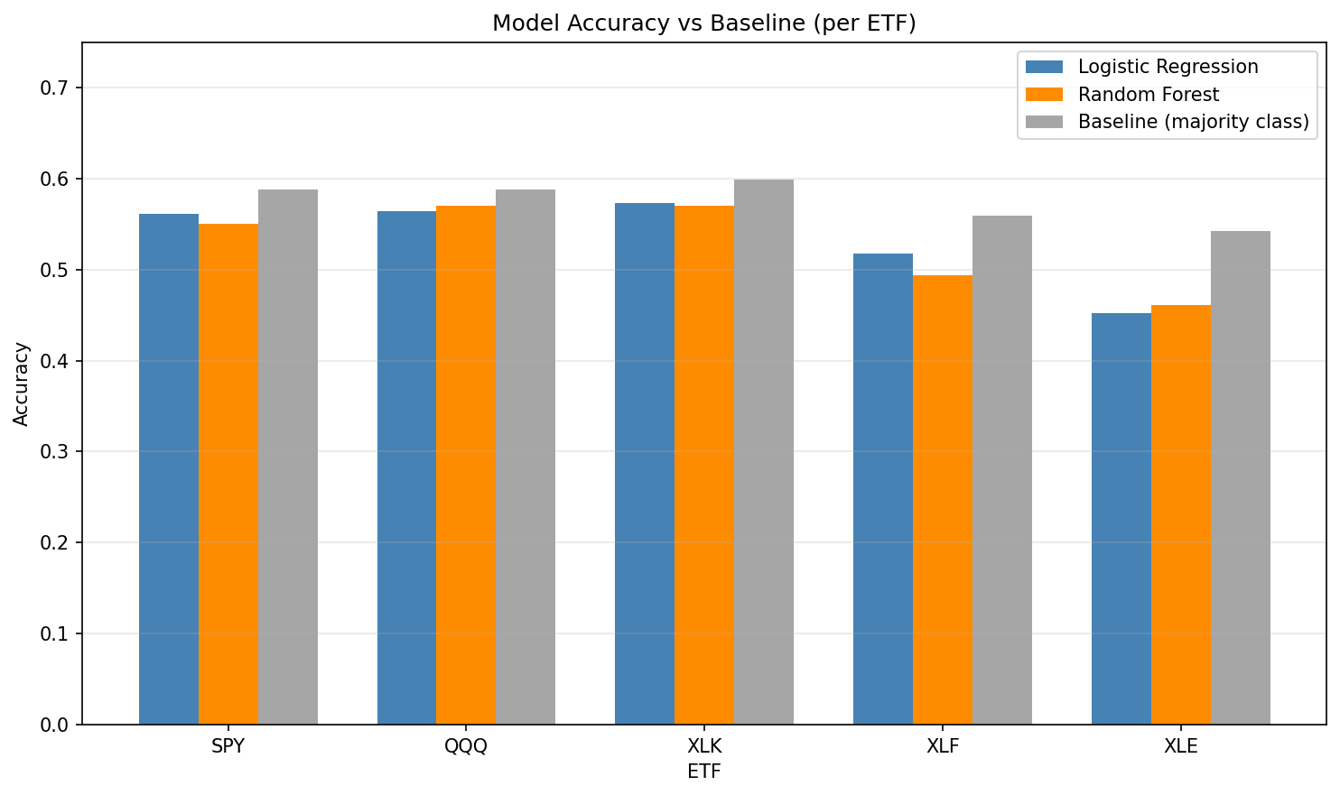
Figure 1. Model accuracy versus majority-class baseline. Baseline (gray) exceeds both models on every ETF.
The diagnostic AUC-ROC analysis (Figure 2) reinforces the headline result. AUC-ROC measures the model's ability to discriminate between "up" and "down" days across all decision thresholds; a value of 0.50 indicates random-chance performance, while 1.00 indicates perfect prediction. All ten model-ETF combinations produce AUC values between 0.43 and 0.52, it is essentially indistinguishable from coin flipping. Both models' ROC curves closely track the diagonal "random" line, confirming that no decision threshold transforms either model into a useful predictor.
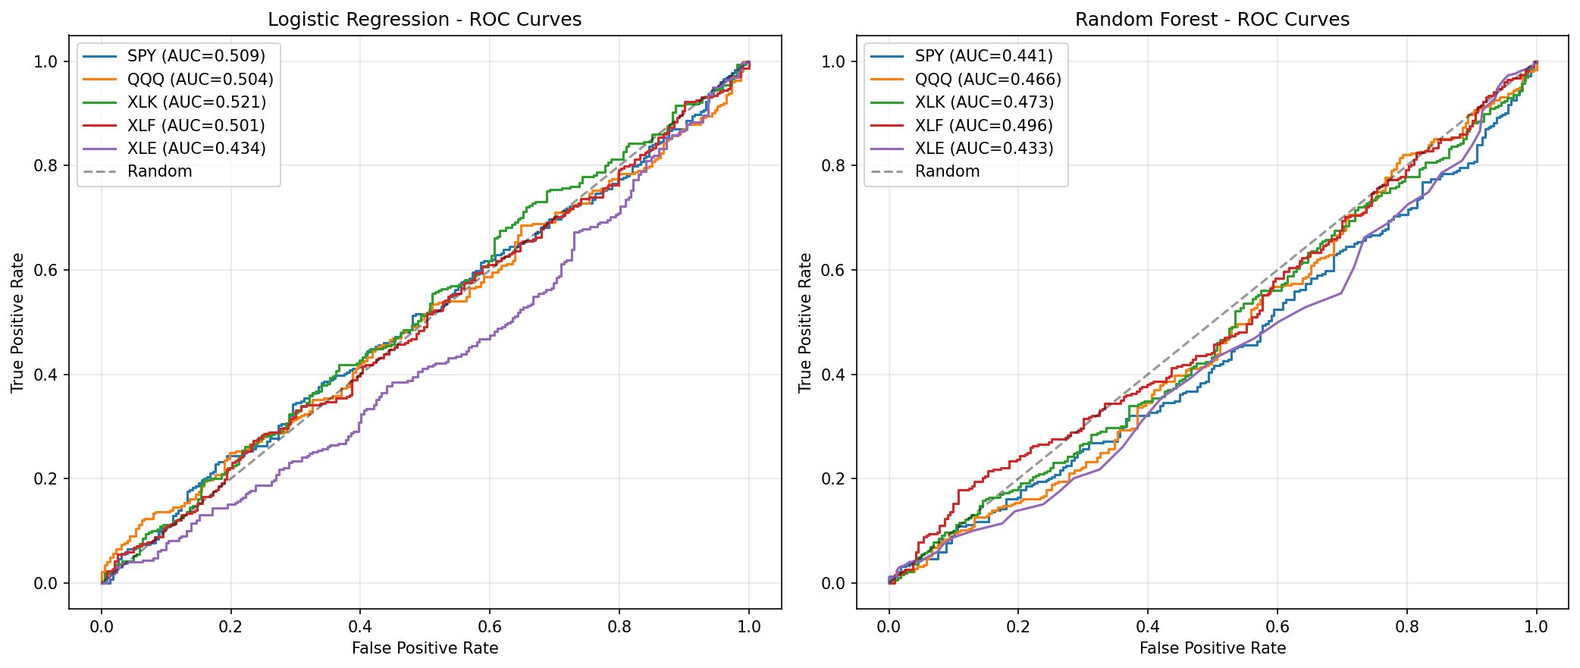
Figure 2. ROC curves for Logistic Regression (left) and Random Forest (right). Curves track the random-chance diagonal for all five ETFs.
High recall (0.85 to 0.95) paired with mediocre precision (0.55 to 0.60) on most ETFs reveals an important diagnostic: both models are essentially predicting "up" for the vast majority of test days. They catch nearly every actual "up" day, but they also flag many "down" days incorrectly. This is the mathematical signature of a model defaulting to the majority class because no usable signal can be extracted from the features.
Feature importance and coefficient analysis confirm the same conclusion from a different angle. In Logistic Regression, the largest coefficient in absolute value across all ETFs was 0.042 (for the dummy variable representing the month of March). In a model with genuine predictive power, top coefficients would typically reach 0.5 or higher. In Random Forest, importance was distributed nearly evenly across the technical features, with each contributing between 8 and 10 percent — none dominated. When all features look equally "important" at low levels, the model is grasping at noise rather than capturing real signal.
5. Discussion
Our findings are consistent with the weak-form Efficient Market Hypothesis, which holds that all publicly available historical price and volume information is already reflected in current prices. Under this hypothesis, technical features alone (derived entirely from past prices and trading volume) cannot reliably forecast future direction, because any exploitable pattern would have already been used by professional traders. The convergence between Logistic Regression and Random Forest on this problem is itself informative: if there were a non-linear relationship that the linear model failed to capture, Random Forest should have detected it. The fact that both models perform equivalently (and both fail to beat the baseline) suggests there is little to no structure in the chosen feature set at the daily horizon.
It is important to note that this result does not imply that all financial prediction is futile. It indicates only that technical features at the daily frequency are insufficient. Alternative data sources such as news sentiment, options-implied volatility, order-flow data, and macroeconomic indicators may carry information not captured by past prices. Likewise, longer prediction horizons (weekly or monthly returns) may reveal stronger signals as short-term noise washes out. Regime-aware models that adapt to changing market conditions could also outperform a single static model.
6. Conclusion
This project applied two machine learning models: Logistic Regression and Random Forest to the task of predicting next-day directional movement in five major U.S. sector ETFs over an eleven-year period. The methodology followed rigorous practices for time-series machine learning: time-based train/test splits, cross-validated hyperparameter tuning with Time Series Split, comparison to a majority class baseline, and multiple evaluation metrics including AUC-ROC. Across all five ETFs, neither model beat the baseline, and Random Forest provided no advantage over Logistic Regression. These results suggest that daily ETF direction cannot be reliably predicted from historical price and volume data alone which is consistent with the weak-form Efficient Market Hypothesis and informative both as an academic result and as a practical caution for retail investment strategies.

